**Lab#5**

**Objective :**To illustrate the concepts of arrays as class member data and arrays of objects through hands-on practice.

**Arrays as Class Member Data**: Arrays can be declared as the members of a class. The arrays can be declared as private, public or protected members of the class.

**Arrays of Objects**: Like array of other user-defined [data type](http://ecomputernotes.com/java/data-type-variable-and-array/explain-data-types-in-java)s, an array of type class can also be created. The array of type class contains the objects of the class as its individual elements. Thus, an array of a class type is also known as an array of objects. An array of objects is declared in the same way as an array of any built-in data type.

The syntax for declaring an array of objects is

     class_name array_name [size] ;

**Lab Tasks:**

* Write codes, compile and run.
* Write output(s) of code in below given boxes.
* Write another code (program) that demonstrates concepts of array of objects and arrays as member data.

.

**Program 1 (Code):**

#include <iostream>

using namespace std;

class Stack

{

private:

enum { MAX = 10 }; //(non-standard syntax)

int st[MAX]; //stack: array of integers

int top; //number of top of stack

public:

Stack() //constructor

{ top = 0; }

void push(int var) //put number on stack

{ st[++top] = var; }

int pop() //take number off stack

{ return st[top--]; }

};

int main()

{

Stack s1;

s1.push(11);

s1.push(22);

cout << “1: “ << s1.pop() << endl; //22

cout << “2: “ << s1.pop() << endl; //11

s1.push(33);

s1.push(44);

s1.push(55);

s1.push(66);

cout << “3: “ << s1.pop() << endl;

cout << “4: “ << s1.pop() << endl;

cout << “5: “ << s1.pop() << endl;

cout << “6: “ << s1.pop() << endl;

getch();

}

**OUTPUT:**

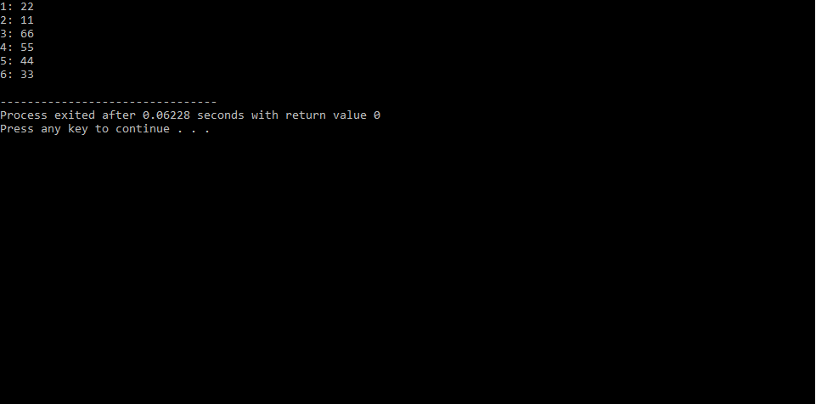

**Program 2 (Code):**

#include <iostream>

using namespace std;

class Distance // Distance class

{

private:

int feet;

float inches;

public:

void getdist() //get length from user

{

cout << “\n Enter feet: “; cin >> feet;

cout << “ Enter inches: “; cin >> inches;

}

void showdist() const //display distance

{

cout << feet << “\’-” << inches << ‘\”’; }

};

int main()

{

Distance dist[100]; //array of distances

int n=0; //count the entries

char ans; //user response (‘y’ or ‘n’)

cout << endl;

do { //get distances from user

cout << “Enter distance number “ << n+1;

dist[n++].getdist(); //store distance in array

cout << “Enter another (y/n)?: “;

cin >> ans;

} while( ans != ‘n’ ); //quit if user types ‘n’

for(int j=0; j<n; j++) //display all distances

{

cout << “\nDistance number “ << j+1 << “ is “;

dist[j].showdist();

}

cout << endl;

return 0;}

**OUTPUT:**

